Plickers is a student-response system that requires only one classroom device, be it an iPad, iPhone, or an Android device. Students are assigned paper code cards that are used as their “clickers”. The teacher displays assessment or survey questions, students respond by holding up their code cards and teacher collects data by scanning them.

1) Download Plickers app for teacher iOS device here.

2) Print Plickers cards here.

Setting Up Classes
3) Create a free teacher account at Plickers.com

4) Add a new class
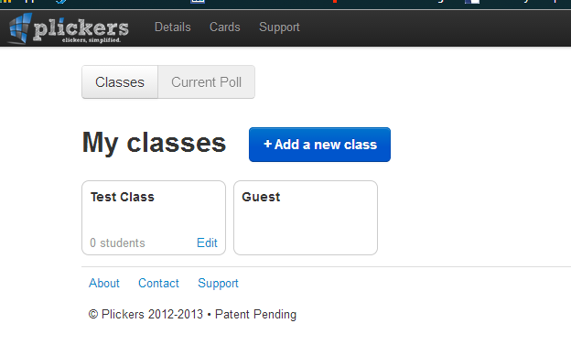

5) Add students by entering their name and hit “enter”. Plickers will automatically assign a card number to that student.

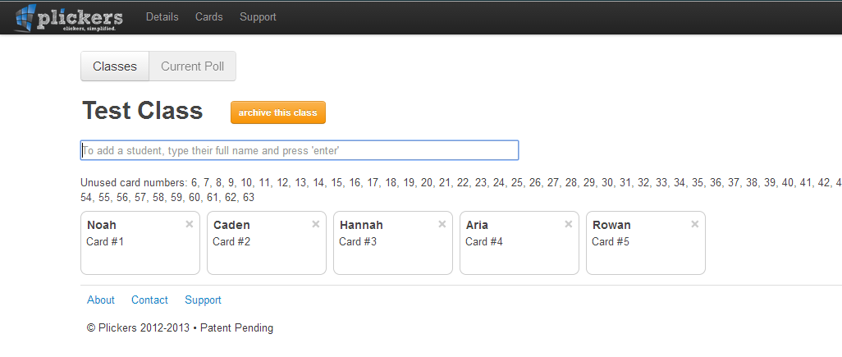

Creating/adding questions on the Plickers iOS device
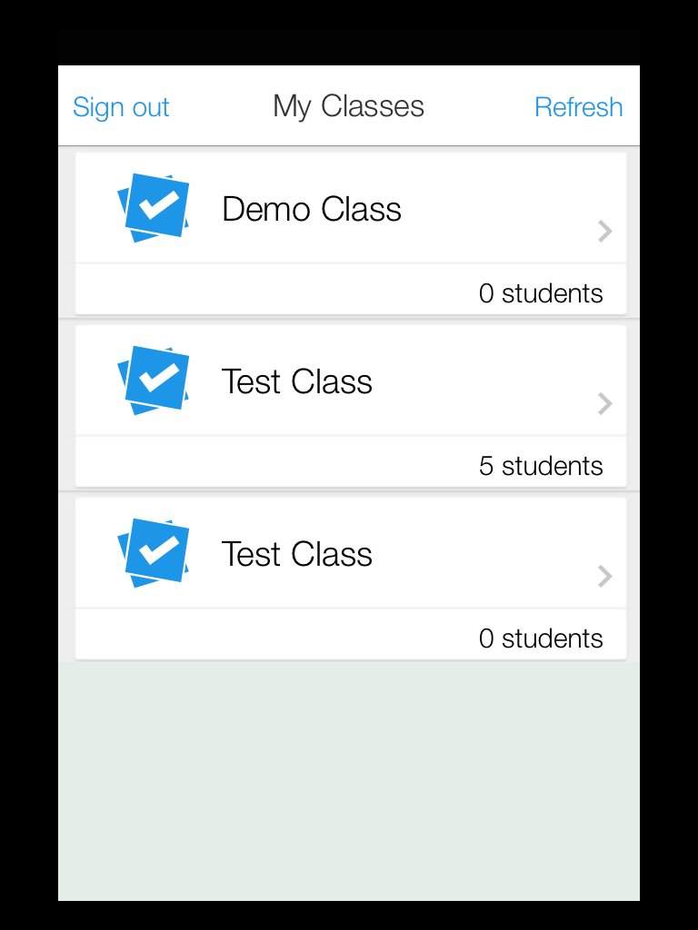
6) On the iPad Plickers app, select the class for which you are creating a question.



7) Create a new question by selecting the “+” icon on the lower portion of the screen.

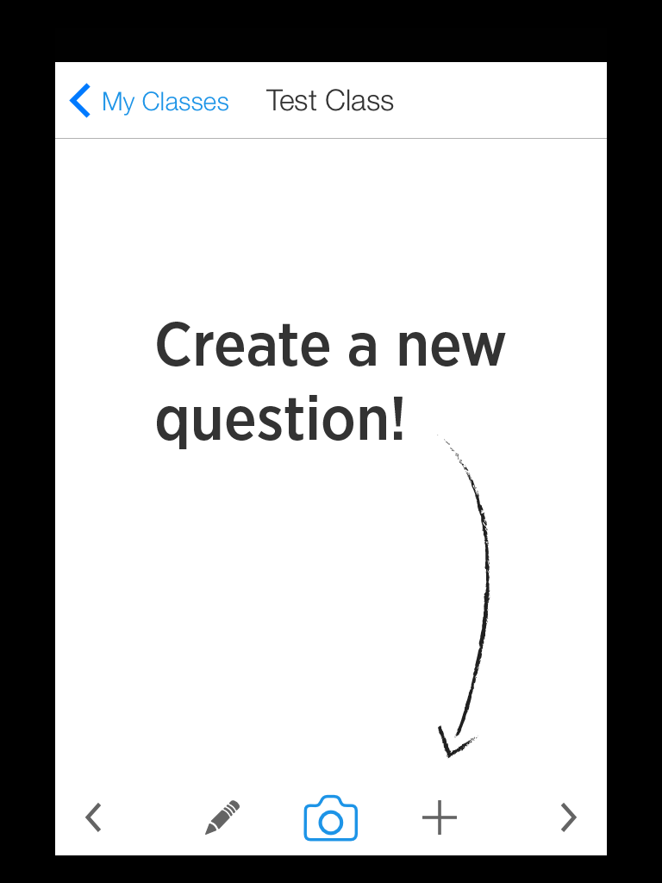

8) Label your question: this is just for teacher reference. You can enter the whole question stem or just a keyword. The actual questions and answer choices will need to be displayed for your students - via a data projector and digital mode of presenting the question, classroom whiteboard, or paper-based questions.
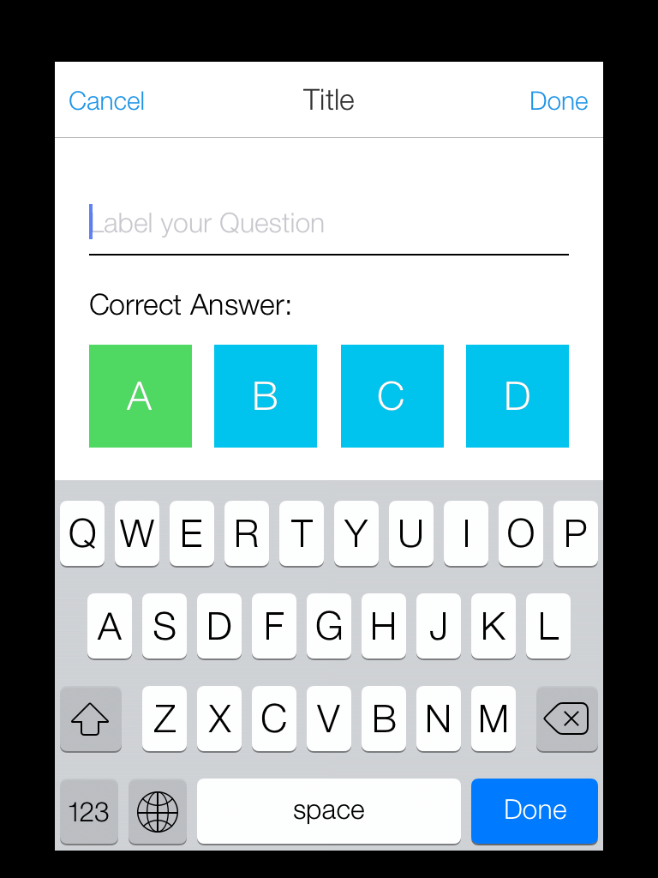




9) Set the correct answer(s) on the Plickers app. You can also choose to scan student response cards without a correct answer set through the app. This may be helpful for surveys or questions with more than one answer.

10) Tap “Done” to save the answer.

Record student responses with the Plickers app
11) Display the question(s) for student reference in your classroom.

12) Provide each student the Plickers card number to which he or she was assigned when you set up the class.

13) Open the Plickers app on your iPad and select the correct class. From the appropriate question screen, select the camera icon from the lower menu.
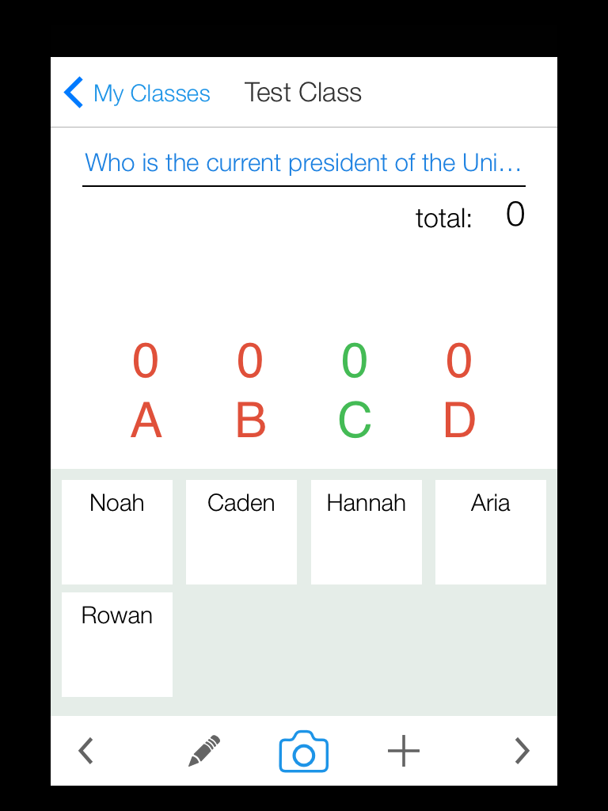



14) Hold your iPad vertically to scan student response cards. Students will need to position their cards so that their intended answer choice is at the top of the card.

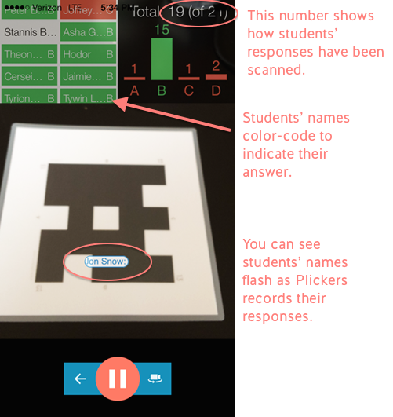

15) Once you have collected all student responses, select the pause icon at the lower portion of the screen.

16) To return to the question screen and view the data for student responses, select the back arrow.

Reviewing Student Responses Online

- Sign into your online account and select the class for which you would like to review student response data.

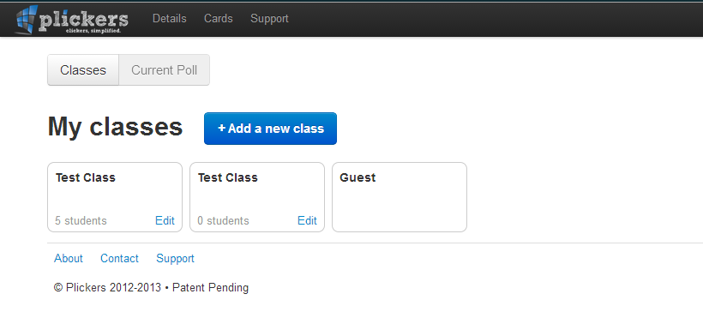

- Select from the list of polls under the “classes” tab.

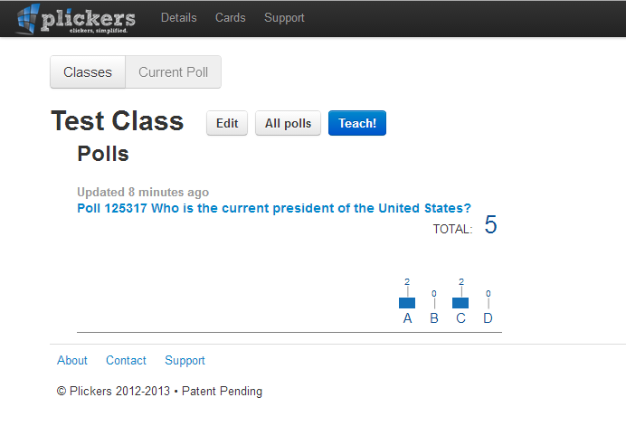

- The results screen will display a bar graph of student responses and you will also be able to view individual student responses.

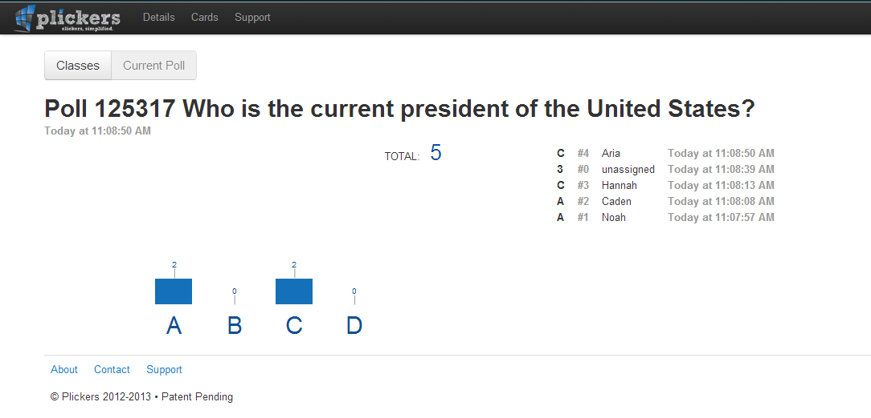

Reviewing Student Responses on iPad

- After collecting student responses and selecting the back arrow, you will automatically be taken to the data view screen for that question.



- To view data for other questions, return to the class homescreen. Use the right and left arrows from the lower menu to scroll between individual questions and their associated student response data.



